|  |  |
| --- | --- |
| Diagram, engineering drawing  Description automatically generated  Assembly instructions  Of Angle post lamp | Htet Paing Aung |

Step 1

Insert the threaded inserts into the bottom hole of the U shape wooden piece (lamp base) and attach the base to the U shape wooden piece (lamp base) by using screw (M8) and base washer.

Step 2

Align the 6mm inner screw holder tube to the bottom 3mm hole of lamp base and insert the M3 threaded bar into it.

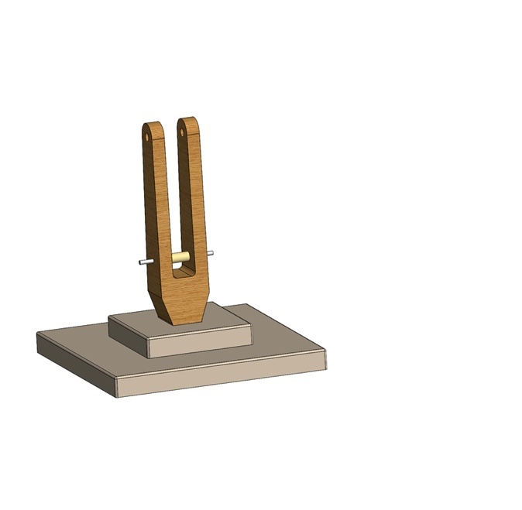

Step 3

Put the biding pin on both sides of M3 threaded bar.

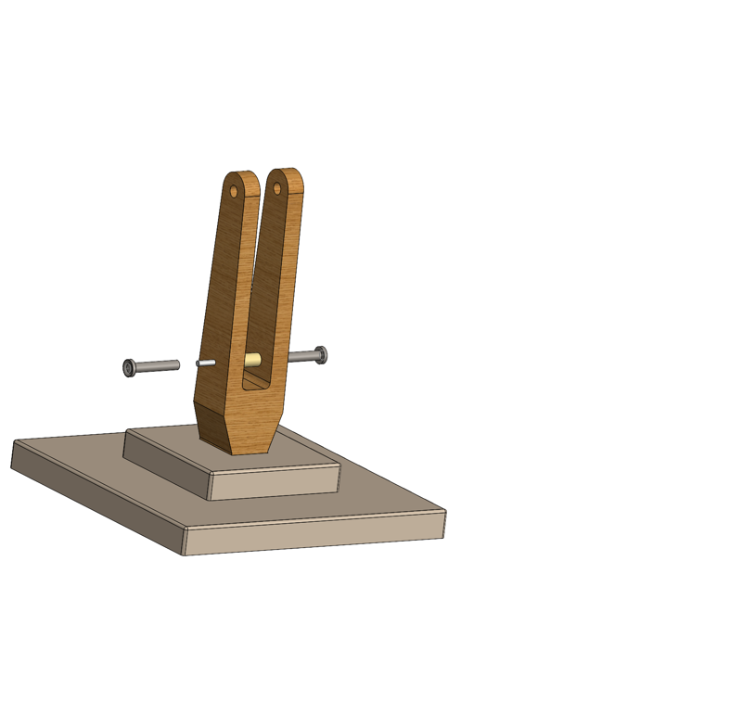

Step 4

Align and inserts the threaded inserts for lamp base upper screws.

Step 5

Align the short and flat/straight part of outer wooden arms to the lamp base and insert the M5 14.5mm screw to connect between them on both sides of the middle hole.

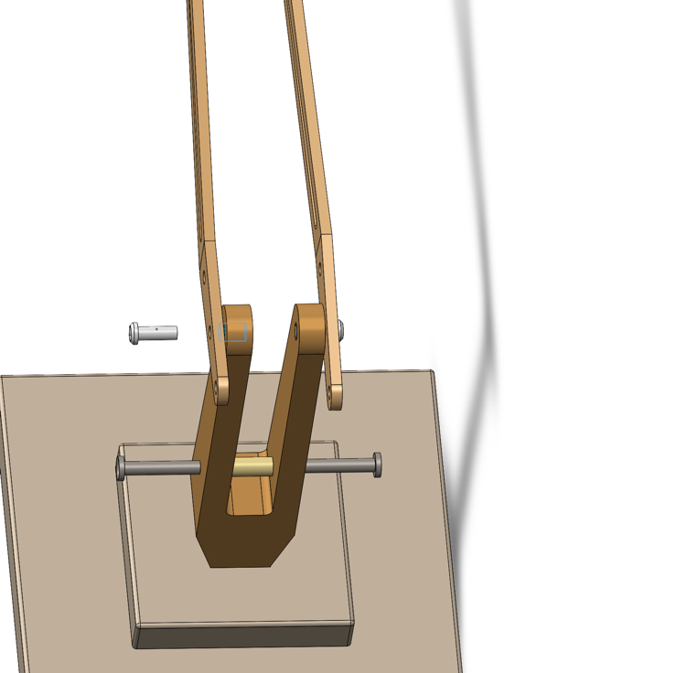

Step 6

Align the biding pen, 3mm screw and the hole of the outer wooden arms and attach together in the outer holes of the wooden arms.

Step 7

Align the angle poise connector and two washers for M5 threaded bar in the inside of the two outer wooden arms. Next, insert the threaded bar (M5 54mm) altogether with two thumb screw(M5).

Step 8

Align 1st tier inner metal arm to the inside of the other holes of the connector and join them together with threaded bar (M5 22mm). After that, fill up two blank holes of 1st tier inner metal arm with (3mmx10mm rod).

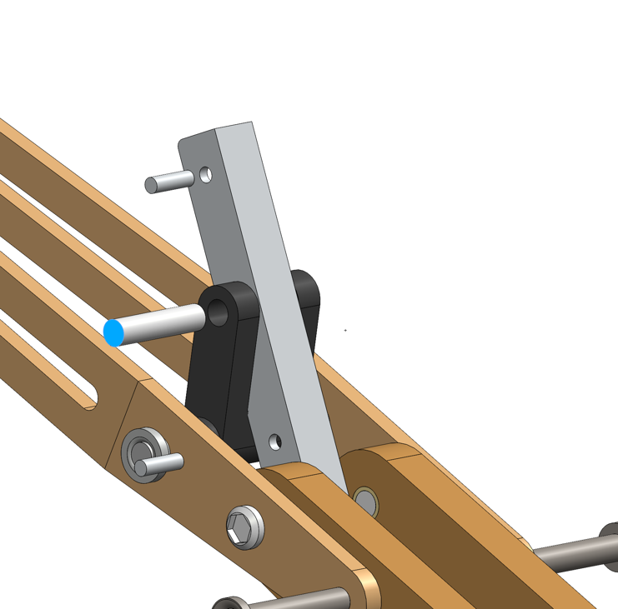

Step 9

Align the outer two holes of 2nd tier inner arm to the two holes of 1st tier arm and insert the M8 Allen bolt (short) with M8 Allen bolt head. Followingly, align the inner two holes of 2nd tier inner arm to the 1st tier arm’s two holes and attach the M8 Allen bolt (long) with M8 Allen bolt head.

Step 10

Connect the angle poise Yoke to the top of tier 2 inner arm and attach those two altogether with 3mmyoke refill cylinder rod. Followingly, attach the wire holders to both tier1 and tier2 inner arms.

Step 11

Next, put two reinforcement M5 threaded inserts into the two holes of Angle poise lampshade reinforcement.

Step 12

Put angle poise lampshade reinforcement into the lamp head. Next, align the holes of both yoke, lamp head and lampshade reinforcement to attach together with Yoke M5 screw.

Step 13

Attach the light fitting into the top of the lamp head.

